Software Requirements Specification
for
PENTACKLES
Version 2.0 approved.
Prepared by Aakansha Tyagi
Aakriti Gupta
Ayush Jaiswal
Ayush Tyagi
KIET Group of Institutions Delhi-NCR
20April2023
Table of Contents
Table of Contents ii
Revision History ii
1. Introduction 1
1.1 Purpose 1
1.2 Document Conventions 1
1.3 Intended Audience and Reading Suggestions 1
1.4 Product Scope 2
1.5 References 3
2. Overall Description 3
2.1 Product Perspective 3
2.2 Product Functions 4
2.3 User Classes and Characteristics 4
2.4 Operating Environment 5
2.5 Design and Implementation Constraints 5
3. External Interface Requirements 6
3.1 User Interfaces 6
3.2 Software Interfaces 6
4. System Features 7
4.1 System Feature 1 Error! Bookmark not defined.
5. Other Nonfunctional Requirements 8
5.1 Performance Requirements 8
5.2 Safety Requirements 9
5.3 Security Requirements 9
5.4 Software Quality Attributes 9
Appendix A: Glossary Error! Bookmark not defined.
Appendix B: Analysis Models 11
Appendix C: To Be Determined List 12

Revision History
Name | Date | Reason For Changes | Version
Pentackles | 13-04-23 | Some information is not sufficient and SRS is not effective | 1.0

Introduction

Purpose
The purpose of a heart disease prediction system website is to provide users with an online platform where they can assess their risk of developing heart disease. This website typically uses a sophisticated algorithm that analyzes various risk factors such as age, gender, medical history, lifestyle habits, and family history of heart disease. The primary objective of such a website is to raise awareness about heart disease and educate users on the risk factors associated with it. By providing users with a personalized risk assessment, the website can encourage individuals to take proactive measures to reduce their risk of heart disease, such as making lifestyle changes, seeking medical advice, and adopting healthy habits.

Document Conventions
Font and Formatting: Use a consistent font and formatting throughout the document to ensure readability and consistency. For example, use a sans-serif font like Arial or Helvetica, and use bold or italic text sparingly to emphasize important points.

Section Headings: Use clear and descriptive headings for each section of the SRS to help readers quickly find the information they need. For example, use "Introduction" for the opening section, "Functional Requirements" for the section describing the system's features, and "Non-functional Requirements" for the section describing performance and quality attributes.

Requirement Numbering: Use a consistent numbering scheme for each requirement statement to facilitate traceability and management. For example, use a hierarchical numbering scheme like "1.1.2" to indicate the section, subsection, and requirement number.

Priority and Importance: Use a clear and consistent priority scheme to indicate the relative importance of each requirement. For example, use "High", "Medium", and "Low" to indicate the urgency and criticality of each requirement.

Dependencies and Relationships: Clearly state any dependencies or relationships between requirements to help readers understand the overall structure and impact of the system. For example, indicate when one requirement is dependent on another, or when a set of requirements are related to a specific feature or function.

Glossary and Definitions: Include a glossary of terms and definitions to clarify any technical or domain-specific terms used in the document. For example, include definitions for terms like "Detection system", "Logistic regression", and "real time value" to ensure a common understanding among all.

Intended Audience and Reading Suggestions
Developers: This document will be primarily used by the development team to understand the functional and non-functional requirements of the heart disease prediction system.
Project Managers: This document will be used by the project managers to plan and monitor the project's progress and ensure that the requirements are met.

Testers: This document will be used by the testing team to develop test cases and ensure that the system meets the specified requirements.

Documentation Writers: This document will be used by the documentation team to create user manuals and other instructional materials.

Reading Suggestions: For an overview of the system's purpose and scope, start with the Introduction section. For a detailed description of the system's functional requirements, refer to the Functional Requirements section. For a description of the system's non-functional requirements, refer to the Non-functional Requirements section .Developers should focus on the functional and non-functional requirements, while testers should focus on the testing section. Project managers should review the entire document to ensure that the project is on track and that all requirements are met.

Product Scope
Risk assessment: The system should include a questionnaire or survey that allows users to input their personal information, including age, gender, medical history, lifestyle habits, and family history of heart disease. The system should then use this information to calculate the user's risk of developing heart disease.

Prediction algorithm: The system should use a sophisticated algorithm to analyze the user's risk factors and calculate the likelihood of developing heart disease. This algorithm should be based on scientific research and statistical analysis.

Recommendations: The system should provide personalized recommendations for users based on their risk assessment and prediction results. These recommendations should include lifestyle changes, healthy habits, and medical advice, as appropriate.

Educational resources: The system should provide educational resources and tools to help users learn more about heart disease and how to reduce their risk. These resources may include articles, videos, infographics, and other multimedia content.

Tracking and monitoring: The system should allow users to track their progress over time and monitor their risk factors. This may include tracking weight, blood pressure, cholesterol levels, and other relevant health metrics.

Integration with healthcare providers: The system should be integrated with healthcare providers to allow users to share their risk assessment and prediction results with their doctors or other healthcare professionals.

References
[1] Ujma Ansari, Jyoti Soni, Dipesh Sharma, Sunita Soni. “Predictive Data Mining for Medical Diagnosis: An Overview of Heart Disease Prediction”, 258493784_Predictive_Data_Mining_for _Medical_Diagnosis_An_Overview_of_Heart_Disease_Prediction. March 2011Data Mining in Healthcare for Heart Diseases

[2] C. Beyene, P. Kamat, “Survey on Prediction and Analysis the Occurrence of Heart Disease UsingdataMiningTechniques”https://www.researchgate.net/publication/323277772_Survey_on_prediction_ananalysis_the_occurrence_of_heart_disease_using_data_mining_techniques, 118(8):165-173 · January 2018

[3] Muhammad Usama Riaz, SHAHID MEHMOOD AWAN, ABDUL GHAFFAR KHAN, “PREDICTION OF HEART DISEASE USING ARTIFICIAL NEURAL NETWORK”, https://www.researchgate.net/publication/328630348_PREDICTION_OF_HEART_DISEASE_USING_ARTIFICIAL_N EURAL_NETWORK. October 2018.

[4] Umair Shafique, Irfan Ul Mustafa, Haseeb Qaiser, Fiaz Majeed, “Data Mining in Healthcare for HeartDiseases”,https://www.researchgate.net/publication/274718934_Data_Mining_in_Healthcare_for_Heart_Diseases. March 2015.

[5] Komal Kumar Napa, G.SarikaSindhu, D.Krishna Prashanthi, A.ShaeenSulthana, “Analysis and Prediction of Cardio Vascular Disease using Machine Learning Classifiers”,
https://www.researchgate.net/publication/340885231_Analysis_and_Prediction_of_Cardio_Vascular_Disease_using_Machine_Learning_Classifiers, April 2020

Overall Description

Website Perspective
User interface: The website should have a clean and intuitive interface that makes it easy for users to input their personal information, access their risk assessment results, and navigate to different sections of the site.

Security and privacy: The website should prioritize the security and privacy of user information. This includes using secure servers, encrypting user data, and ensuring that user information is not shared with third parties without explicit consent.

Mobile responsiveness: The website should be designed to be mobile responsive, meaning that it should be easily accessible and usable on mobile devices such as smartphones and tablets.

Personalization: The website should provide personalized recommendations and educational resources based on each user's risk assessment results.

Engagement: The website should be engaging and interactive, with features such as quizzes, interactive tools, and social media integration to encourage users to explore and share the site with others.

Website Functions
Risk assessment: The system should include a questionnaire or survey that allows users to input their personal information, including age, gender, medical history, lifestyle habits, and family history of heart disease. The system should then use this information to calculate the user's risk of developing heart disease.

Prediction algorithm: The system should use a sophisticated algorithm to analyze the user's risk factors and calculate the likelihood of developing heart disease. This algorithm should be based on scientific research and statistical analysis.

Recommendations: The system should provide personalized recommendations for users based on their risk assessment and prediction results. These recommendations should include lifestyle changes, healthy habits, and medical advice, as appropriate.

Educational resources: The system should provide educational resources and tools to help users learn more about heart disease and how to reduce their risk. These resources may include articles, videos, infographics, and other multimedia content.

Tracking and monitoring: The system should allow users to track their progress over time and monitor their risk factors. This may include tracking weight, blood pressure, cholesterol levels, and other relevant health metrics.

Integration with healthcare providers: The system should be integrated with healthcare providers to allow users to share their risk assessment and prediction results with their doctors or other healthcare professionals.

User Classes and Characteristics
Individuals: Individuals who use the heart disease prediction system may vary in age, gender, and race/ethnicity. They may also have different levels of education, income, and access to healthcare.

Healthcare professionals: Healthcare professionals who use the heart disease prediction system may have different levels of training and experience. They may also have different specialties or areas of focus, such as cardiology, primary care, or public health.

Researchers: Researchers who use the heart disease prediction system may have different levels of expertise in areas such as epidemiology, statistics, and genetics. They may also have different research interests, such as studying the effects of lifestyle factors on heart disease risk.

Operating Environment
Hardware: The heart disease prediction system requires a computer or a server with adequate processing power, memory, and storage capacity to run the prediction algorithm and store user data securely. The system may also require specialized hardware components, such as medical devices for measuring blood pressure, cholesterol levels, or other health metrics.

Software: The heart disease prediction system requires software components, including an operating system, database management system, web server software, and programming frameworks. The software components should be compatible with the hardware components and designed to handle high traffic volumes and user requests.

Internet connectivity: The heart disease prediction system requires a high-speed and reliable internet connection to facilitate user access and data transmission. The system should be designed to handle fluctuations in internet connectivity and network traffic.

Security protocols: The heart disease prediction system should be designed with robust security protocols to protect user data from unauthorized access or data breaches. This includes encryption of user data, secure communication protocols, and regular system backups.

Compliance standards: The heart disease prediction system should comply with relevant data privacy and security regulations, such as HIPAA (Health Insurance Portability and Accountability Act) in the US, GDPR (General Data Protection Regulation) in the European Union, or other local regulations.

Design and Implementation Constraints
Some common design and implementation constraints for our project PENTACKLES include:
Data Availability and Quality: The accuracy and reliability of our Project is highly dependent on the availability and quality of data.

Technological Limitations: Our project may be constrained by the limitations of the available technologies, such as the accuracy and reliability of the heart disease risk assessment algorithms, limitations of hardware or software components, or availability of relevant data sources.

Time Constraints: The development and deployment of our system may be subject to time constraints, such as project timelines or regulatory deadlines.

External Interface Requirements

User Interfaces
Simple and clear design: The user interface should be designed to be simple and clear, with a minimalist layout that highlights the essential information and functionality. Users should be able to navigate the system easily and find the information they need quickly.

Visual aids: The user interface should use visual aids such as graphs, charts, and icons to help users understand the information and data presented. This can help users to identify patterns and trends, making it easier to interpret their results.

User-friendly forms: The user interface should include user-friendly forms that gather the necessary information to assess the user's risk of heart disease. These forms should be easy to understand and complete, with clear instructions and helpful prompts.

Feedback and guidance: The user interface should provide feedback and guidance to users throughout the assessment process. This can include providing tips on healthy lifestyle choices or personalized recommendations to reduce the user's risk of heart disease.

Personalization: The user interface should be designed to provide personalized recommendations and feedback based on the user's specific risk factors and health status. This can help users to feel more engaged with the system and motivated to make positive changes.

Accessibility: The user interface should be accessible to a broad range of users, including those with visual or hearing impairments, or other disabilities. This can include providing alternative text descriptions of images, using high contrast colors, or providing closed captioning for videos.

Software Interfaces
Compatibility: The software interface should be designed to be compatible with the hardware and software components of the system. This includes compatibility with the operating system, programming frameworks, and database management system.

Data management: The software interface should enable the system to manage and store user data securely. This includes data validation, data normalization, and data cleaning to ensure the accuracy and completeness of user data.

Prediction algorithm: The software interface should enable the prediction algorithm to access user data and calculate the user's risk of heart disease based on the data provided. The interface should also enable the algorithm to generate personalized recommendations based on the user's specific risk factors.

Data visualization: The software interface should enable the system to visualize user data and prediction results in a way that is easy to understand and interpret. This can include generating graphs, charts, or other visual aids to highlight patterns and trends.

Security: The software interface should be designed with robust security protocols to protect user data from unauthorized access or data breaches. This includes encryption of user data, secure communication protocols, and regular system backups.

System Features
Some potential system features for heart disease predictor system are Patient Information Input, Risk Factor Assessment, Diagnostic Tests, Machine Learning Algorithms etc.

Description and Priority

Patient Information Input: This feature allows users to input relevant patient information, such as age, gender, family history, medical history, lifestyle factors, and existing health conditions. It is a critical feature as accurate and comprehensive patient information is essential for assessing heart disease risk accurately.

Risk Factor Assessment: This feature assesses and analyzes various risk factors for heart disease, such as high blood pressure, high cholesterol, obesity, smoking, and diabetes This feature is a high priority as it forms the foundation of the heart disease prediction system.

Diagnostic Tests: This feature allows for the input or analysis of results from diagnostic tests, such as blood tests and ECGs, to provide a more comprehensive assessment of cardiovascular health. This feature is important for obtaining objective data to further refine the heart disease risk assessment.

Machine Learning Algorithms: This feature utilizes machine learning algorithms like logistic regression, random forest, support vector machine and decision tree to analyze patient data and identify patterns and correlations related to heart disease risk. This feature is of high priority as it can improve the accuracy and predictive capability of the system by identifying complex relationships between risk factors.
.
4.2 Functional Requirements
Functional requirements are the features and capabilities that a heart disease predictor system must have to effectively perform its intended purpose. Here are some functional requirements for a heart disease predictor system like Patient Data Input, Risk Factor Assessment, Diagnostic Test Integration. Machine Learning Algorithms etc
REQ-1: Patient Data Input: The system should allow for the input of relevant patient data, such as age, gender, family history of heart disease, medical history, lifestyle factors (e.g., smoking, alcohol consumption), and existing health conditions.
REQ-2: Risk Factor Assessment: Our system assess and analyze various risk factors for heart disease, such as high blood pressure, high cholesterol levels, obesity, sedentary lifestyle, smoking, diabetes, and other relevant factors, and calculate an overall risk score using established risk scoring models.

REQ-3: Diagnostic Test Integration: Our system is able to integrate with diagnostic test results, such as blood tests (e.g., lipid profile, glucose levels), electrocardiograms (ECGs), stress tests, or other relevant tests, to provide a more comprehensive assessment of the patient's cardiovascular health

Other Nonfunctional Requirements

Performance Requirements
Accuracy: The system should have a high level of accuracy in predicting the likelihood of heart disease. It should be able to correctly identify patients with heart disease and those without it.

Sensitivity and specificity: The system should have high sensitivity and specificity. Sensitivity refers to the system's ability to correctly identify patients with heart disease, while specificity refers to the system's ability to correctly identify patients without heart disease.

Speed: The system should be fast enough to provide results in a reasonable amount of time. This is particularly important in emergency situations when timely diagnosis and treatment can be critical.

User-friendliness: The system should be user-friendly and easy to use for healthcare professionals who may not have a background in data science or machine learning.

Scalability: The system should be able to handle a large volume of data and be scalable to accommodate an increasing number of patients.

Safety Requirements
Privacy and confidentiality: The system should ensure that patient data is kept private and confidential. This includes protecting patient information from unauthorized access, use, and disclosure.

Ethical considerations: The system should be designed and used in accordance with ethical considerations, such as ensuring that patients are fully informed about the use of their data and giving them the option to opt-out of data sharing.

Transparency: The system should be transparent in how it makes predictions and recommendations. Patients and healthcare professionals should be able to understand how the system works and the factors that are used to make predictions.

Bias and fairness: The system should be designed to minimize bias and ensure fairness in the predictions it makes. This includes ensuring that the system does not discriminate based on factors such as race, gender, or socioeconomic status.

Reliability and accuracy: The system should be reliable and produce accurate results. This is important to ensure that patients receive appropriate care and treatment.

Security Requirements
Data confidentiality: The system should ensure that patient data is kept confidential and protected from unauthorized access, use, or disclosure.

Data integrity: The system should ensure that patient data is accurate and has not been tampered with or altered in any way.

Data availability: The system should ensure that patient data is available when needed by authorized users.

Access control: The system should have appropriate access controls to ensure that only authorized users can access patient data.

Authentication and authorization: The system should require authentication and authorization to ensure that only authorized users can access and modify patient data.

Software Quality Attributes
Reliability: The system should be reliable and consistently produce accurate results over time.

Availability: The system should be available when needed and minimize downtime to ensure that healthcare professionals can access the system when required.

Scalability: The system should be scalable to handle an increasing number of patients and accommodate future growth.

Maintainability: The system should be easy to maintain and modify as needed. This includes ensuring that updates can be made quickly and without disrupting the system's functionality.

Usability: The system should be easy to use for healthcare professionals with varying levels of technical expertise

Appendix A: Glossary
Heart disease: A condition that affects the heart, including coronary artery disease, heart attack, heart failure, and arrhythmias.
Prediction model: A statistical model that uses patient data to predict the likelihood of heart disease.
Machine learning: A type of artificial intelligence that allows a system to learn and improve from experience, without being explicitly programmed.
Algorithm: A set of rules or instructions that a system follows to perform a specific task, such as predicting the likelihood of heart disease.
Risk factors: Factors that increase the likelihood of developing heart disease, such as high blood pressure, high cholesterol, smoking, obesity, and a family history of heart disease.

Appendix B: Analysis Models

ER Diagram
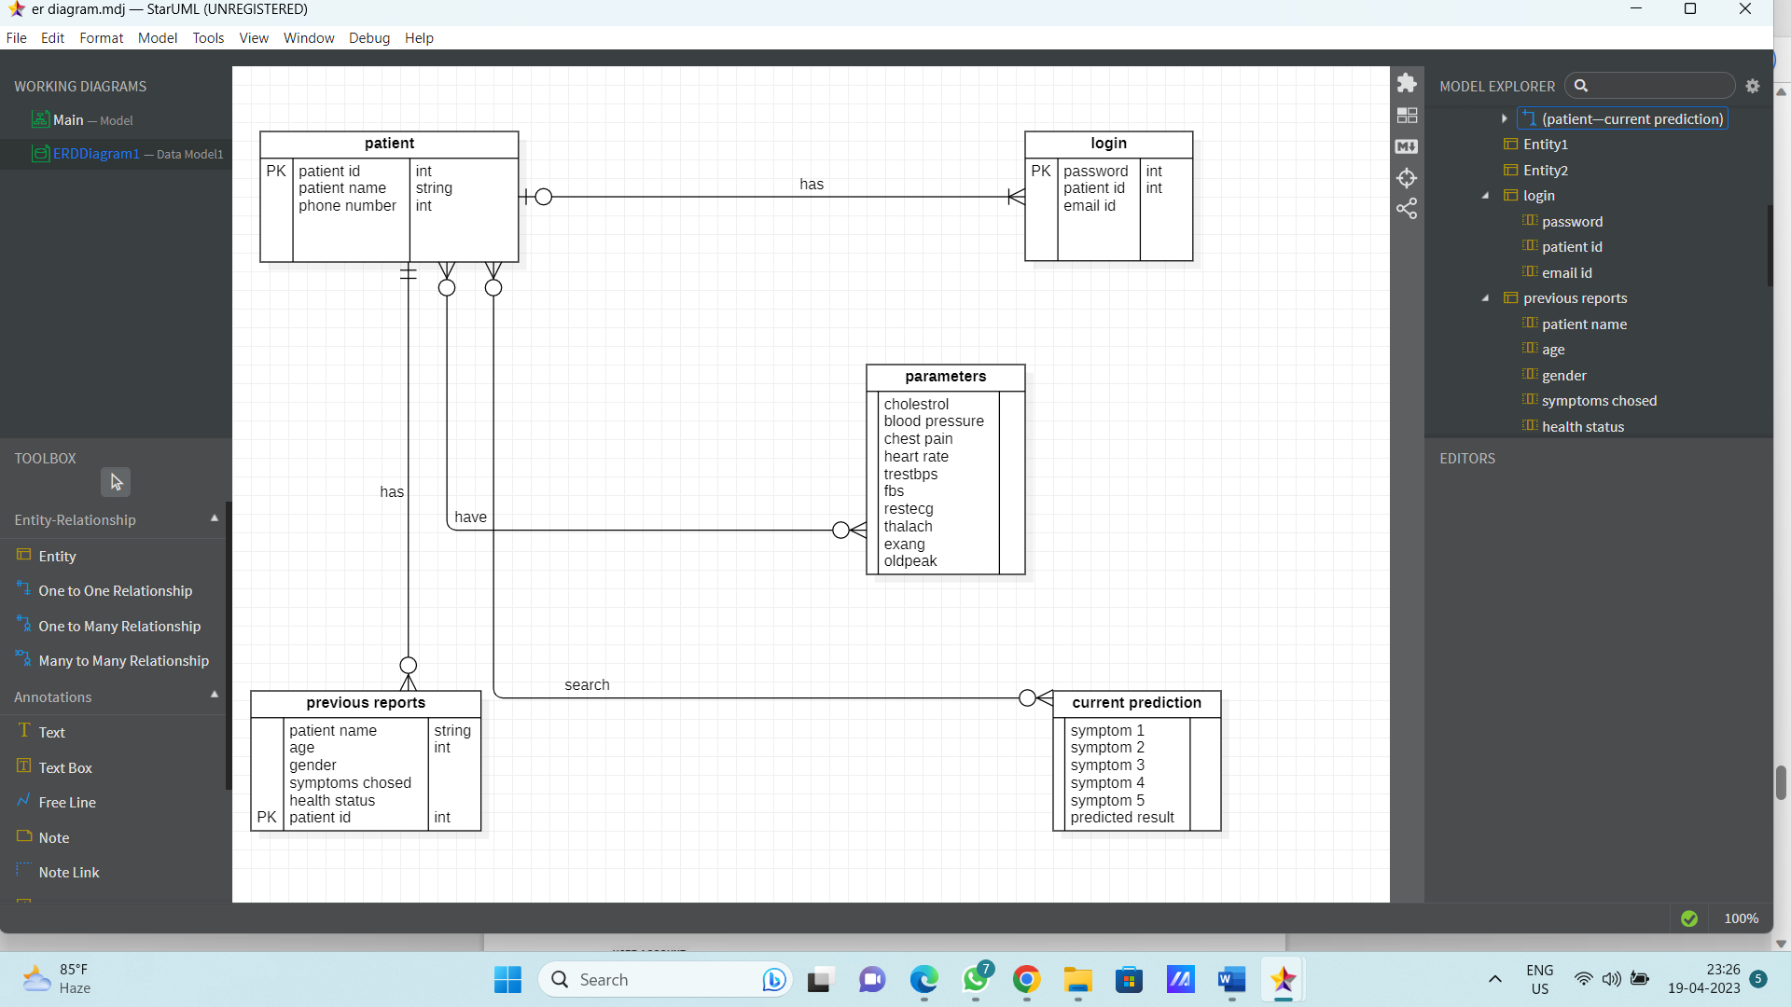

DATA FLOW DIAGRAMS (DFD)
DFD Level -0
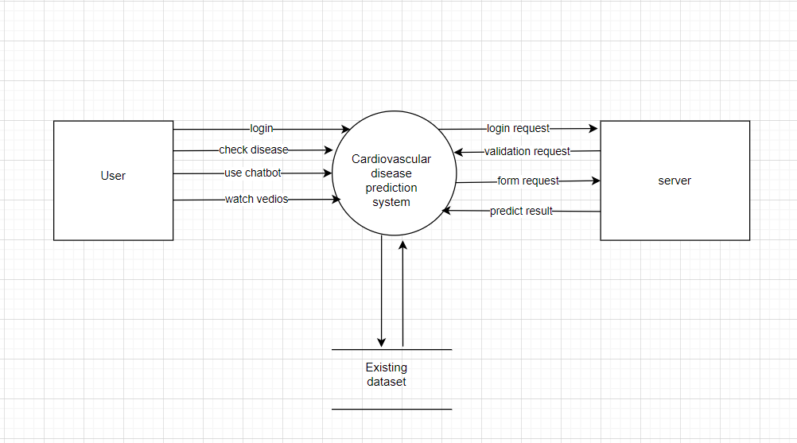

DFD Level-1
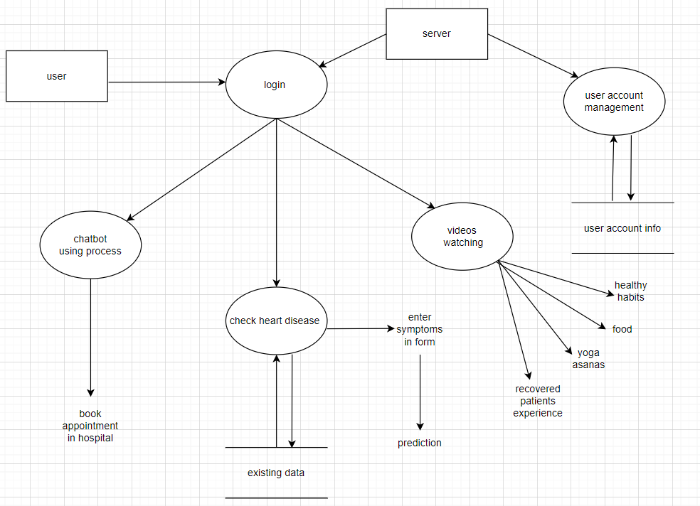

DFD Level-2
- Patient Account

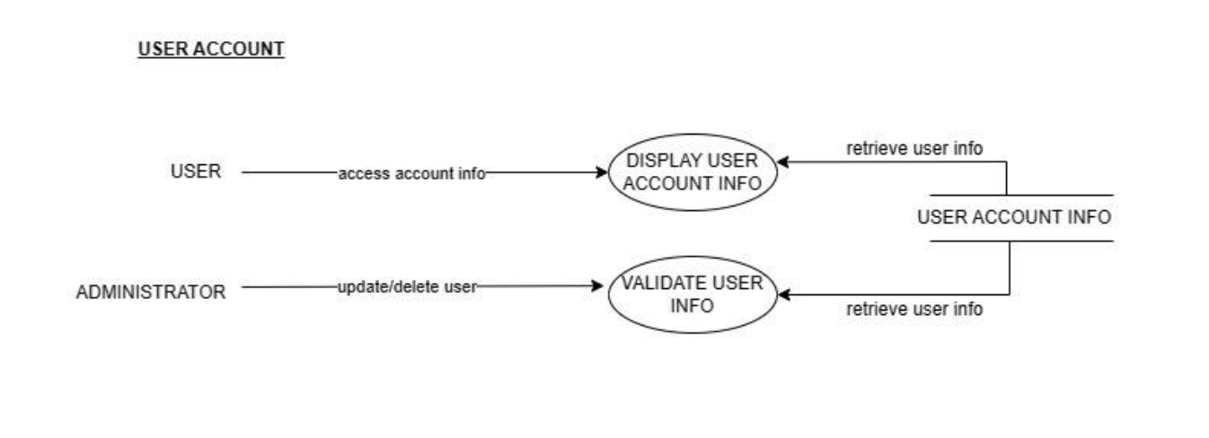

- Login

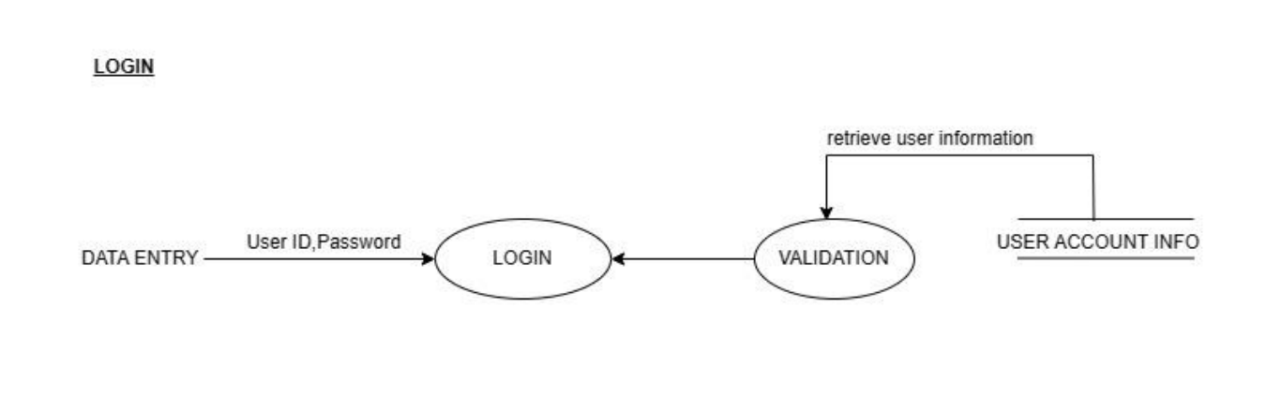
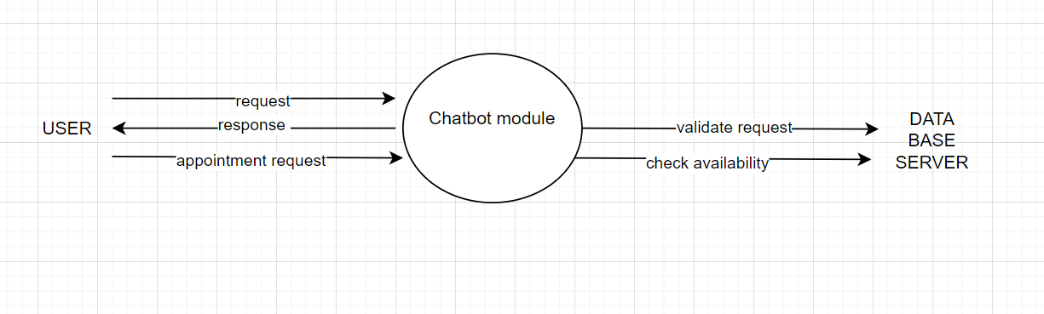
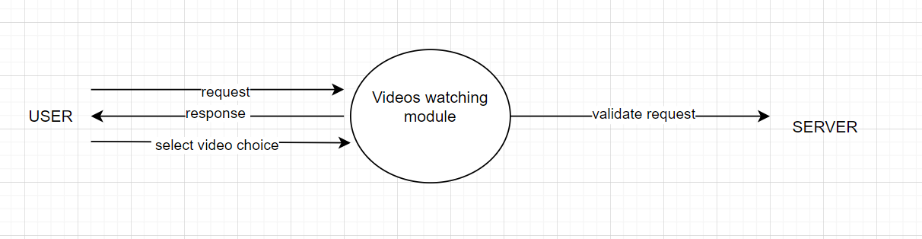
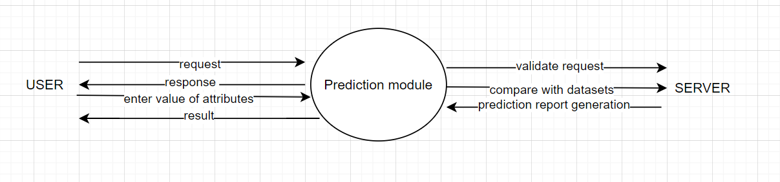USE CASE DIAGRAM
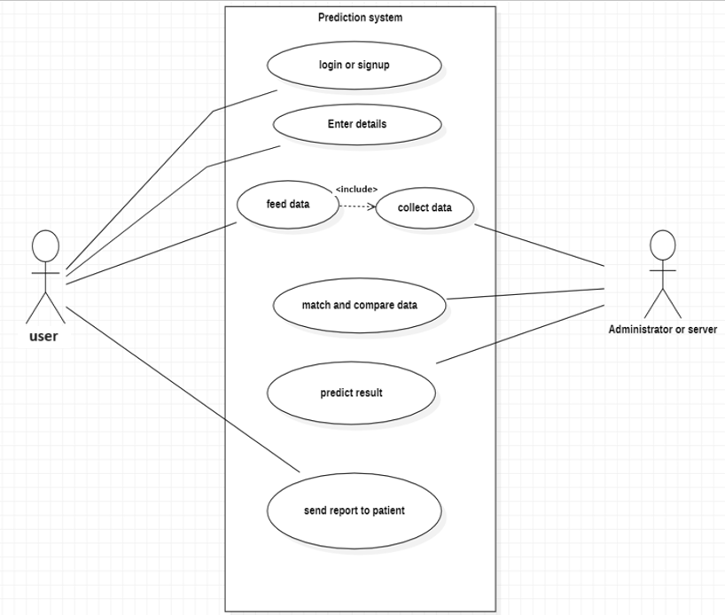

STATE CHART DIAGRAM
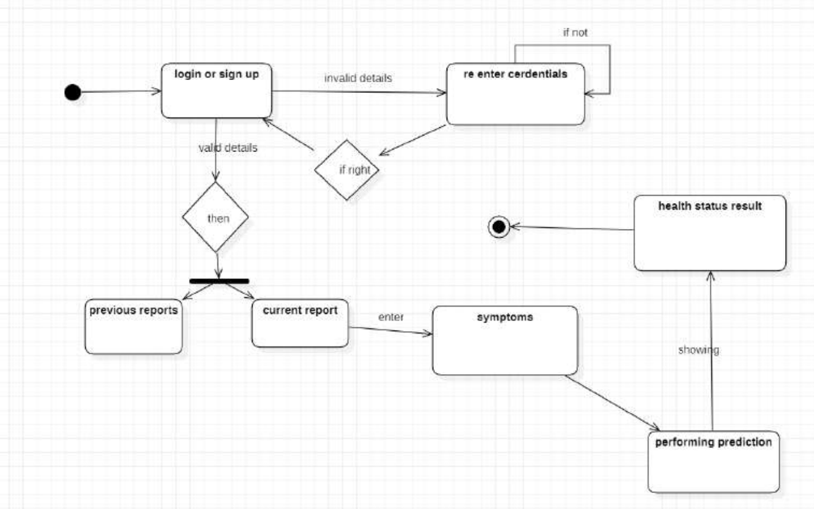

ACTIVITY DIAGRAM
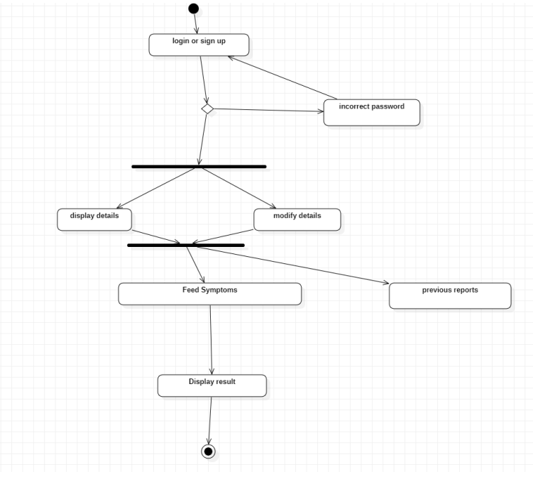

Appendix C: To Be Determined List
Data sources: Determine the sources of patient data to be used in the heart disease prediction system, such as electronic health records, medical imaging, and genetic data.

Performance metrics: Define the specific performance metrics that will be used to evaluate the accuracy and effectiveness of the heart disease prediction system, such as sensitivity, specificity, and positive predictive value.

User interface design: Determine the design of the user interface for the heart disease prediction system to ensure ease of use and efficiency for healthcare professionals.

Integration with existing systems: Determine how the heart disease prediction system will integrate with existing healthcare systems and software, such as electronic health record systems and medical imaging software.

Regulatory compliance: Determine how the heart disease prediction system will comply with applicable regulations, such as HIPAA and GDPR, to ensure patient safety and privacy.

